**Guide to AIM Roles for Azure Fabric Connectors for HA**

In order for the Azure Fabric Connector to make the Azure API calls that move public IPs and modify route tables, the Service Principal (aka App Registration) must have Network Contributor and Virtual Machine Contributor roles. Typically, these are applied at the resource group level and then inherited by the various resources that must be modified. However, it’s useful to know specifically where these roles are required in cases where the resources may be in alternate resource groups.

Network Contributor access must be granted for the following resources:

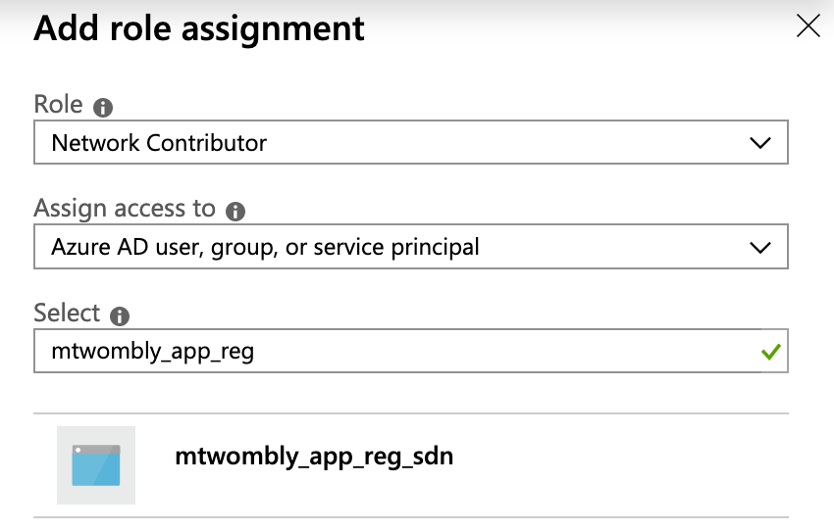

* Virtual Network
* Public IPs
* VNICs Route Tables
* Route Tables

Virtual Machine Contributor is required for any NVA making API calls:

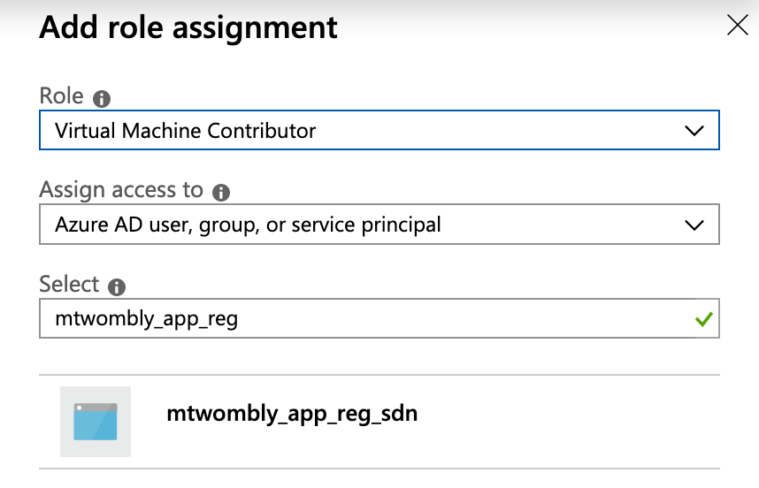

* FortiGate VMs (NVAs)

It’s not unusual for the Virtual Network to exist in secondary resource groups. In those cases, it is not necessary to add a second Fabric/SDN Connector to the FortiGate config, because the VNET isn’t directly referenced by the API calls. However, the API calls do affect the VNIC which is tied to a VNET, so a role must be enabled which permits manipulation of the Virtual Network.

Public IPs and Route Tables can also exist in separate Resource Groups. In these cases, Network Contributor role must be enabled *and* a secondary Fabric/SDN Connector must be enabled for the API calls to reference the resources in context of their resource group.